Adsfadfs striped stripped 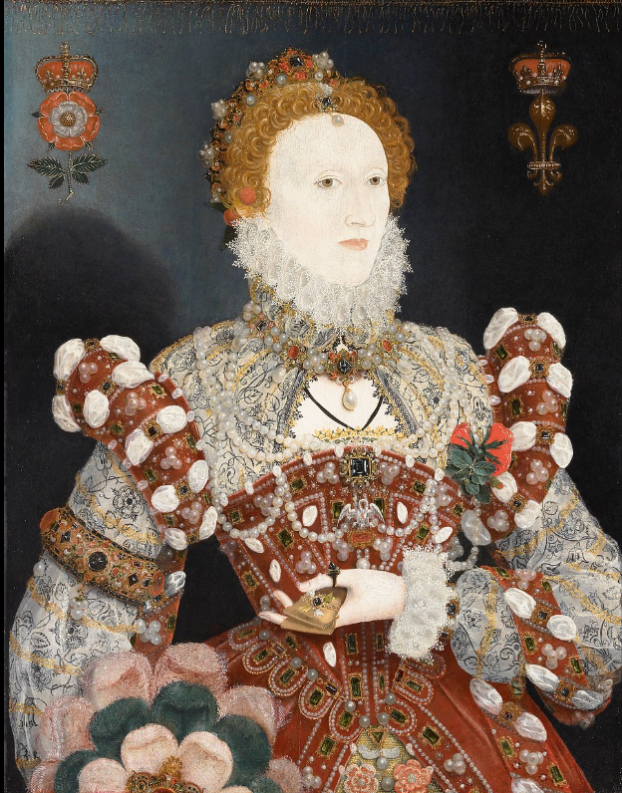 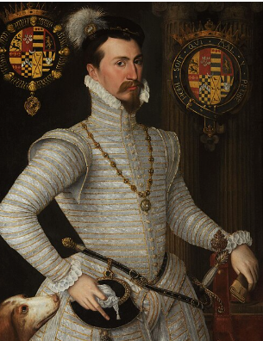 asd 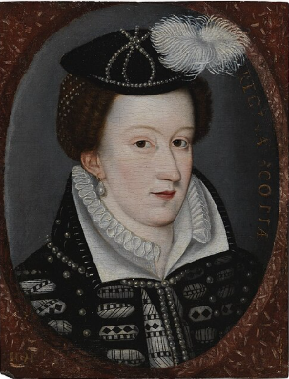 decisive  adf incurred incurred ascension ffff councilors fff decisive kkkkkkkk jhj

Henry VII
KatherineGrey
Jane Grey
Frances Brandon
Elizabeth I
Edward VI
Mary I
James VI of Scotland and
James I of England
Mary Queen of Scots
James V of Scotland
Mary
Margarett
Henry VIII

